Boosting Colorectal Cancer Screening Rates at Quentin N. Burdick Memorial Health Care Facility

Date: May 8, 2025

Interviewees: Maggie Martin and Mikisha Longie

Challenge: Overcoming Barriers to Colorectal Cancer Screening

At Quentin N. Burdick Memorial Health Care Facility (QNBMHCF), increasing colorectal cancer screening rates among patients was a persistent challenge. Many patients underestimated the importance of regular screening, often citing time constraints or believing that a test done years ago was still sufficient. Socioeconomic and health literacy barriers further complicated outreach, particularly among lower-income individuals who lacked understanding of the screening process and its purpose.

The facility also faced system hurdles. The absence of an in-house surgeon for over seen years means that colonoscopies are referred to distant tertiary facilities, creating logistical and financial burdens for patients. FIT (Fecal Immunochemical Test) was the only in-house screening method, and some providers were hesitant to adopt alternatives like Cologuard due to cost concerns and skepticism about its efficacy. Additionally, screening colonoscopies have been intermittently placed on hold when funding is limited through the Purchased/Referred Care (PRC) benefit, limiting access for many patients.

Action: A Multi-Faceted Approach to Drive Change

To address these challenges, the clinic implemented a comprehensive strategy:

* Data Accuracy & Accountability: A thorough chart review ensured screening results were accurately recorded in the EHR. Providers now enter results directly, with nurses only needing to hunt down results for tests completed off site that are not resulted directly back to the facility.
* Incentives: One of the most important keys to completing screening tests has been providing a $25 gas card which is offered to patients who complete screening to help offset travel costs and serving as a motivational reward. Funding for this was originally provided through a grant from the ND Comprehensive Cancer Control program but has more recently been funded through Milestone awards through the ScreeND Program. Going forward, additional funding is being sought through the tribe. Tribal Health Education is responsible to assure that patients receive the incentive card when they complete their screening.
* Education & Outreach:
  + An Exact Sciences Medical Liaison, Jacinta Scott, educated providers and nursing staff on the science behind Cologuard.
  + Community outreach included personal storytelling, mobile unit visits to local hotspots, and a Colorectal Cancer Awareness Walk during Turtle Mountain Days including the “Rollin’ Colon”. Mikisha stated, “Sharing my own experience with Colorectal Cancer has led to many people being screened, especially the younger population who think that they are not old enough for Colorectal Cancer.”
  + Educational signage and bulleting boards throughout the facility encouraged patients to initiate conversations about screening. “Patients would read this information while sitting in the waiting room, and would actually get up and ask the receptionist if they were eligible for screening,” Maggie added.
* Data-Driven Strategy: With guidance from ScreeND, the team began reviewing data on a monthly basis, recognizing trends associated with their efforts. They also became proficient in running reports from I-care which was reflective of clinic performance and helped them identify screening gaps such as the need to target patients aged 45-50.
* Provider Engagement: A friendly competition tracked screening orders by provider pod, fostering accountability ad enthusiasm for screening.
* Policy Advocacy: Persistent efforts to expand screening options led to PRC approval for Cologuard, expanding access and reducing reliance on FIT. This allows average risk patients to be screened every three years, versus annually, and ensures that all patients have access to all available screening options.

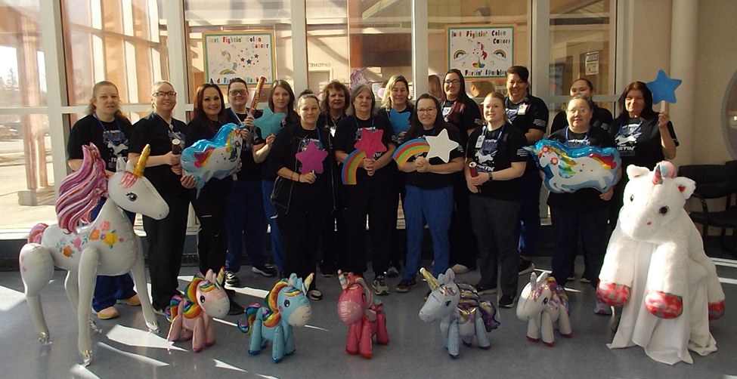

Results: A Culture Shift and Tangible Impact

The results have been remarkable:

* Overall Screening Rate: Using the I-care population health management system to pull rates since September of 2023, QNBMHCF has improved their overall screening rates 10%, a relative improvement of *22.6%*. In addition, they boast a stool test completion rate of 85.71%, the highest of any ScreeND participating team!
* Provider Buy-In: The shift to using Cologuard is very recent and there is incredible enthusiasm around using this method. Exact Sciences has taken great interest in developing processes to efficiently bill PRC for patients who are approved for that benefit. The PRC program has also recently began approving screening colonoscopies again.
* Patient Engagement: The incentive program has been well-received, especially among low-income patients. The structuresd process of card distribution and redemption has reinforced follow-through.
* Early Detection: Several asymptomatic patients tested positive through Cologuard, leading to timely colonoscopies and early diagnoses – an eye-opener for both providers and nurses.

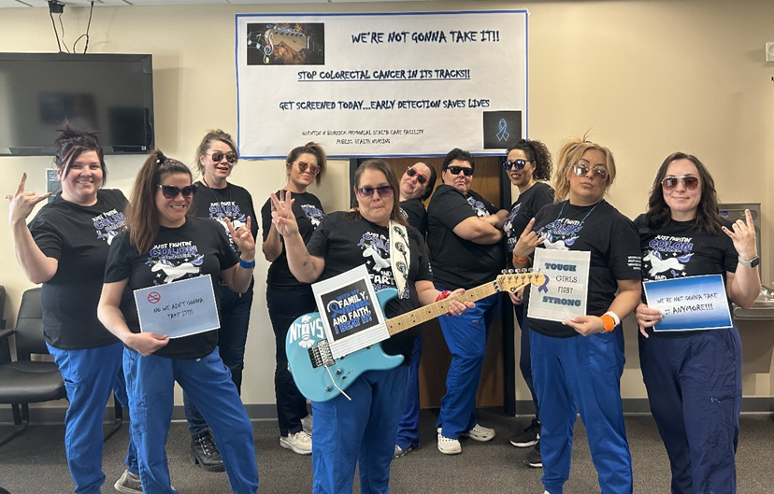

Sustainability: Building on Momentum

“We are not done!” QNBMHCF remains committed to continuous improvement and expanding their reach to assure more patients are screened and supported through the process by sustaining and expanding these efforts:

* A formalized process for assuring patients can access the gas card following completion of Cologuard is being developed. With FIT the approval for an incentive card is processed when the kit is resulted from the in-house lab. With Cologuard, results are received electronically into the EHR, so the approval needs to be assigned to someone with access to patient records within the clinic.
* Ongoing education for both staff and patients.
* Annual Colorectal Cancer Awareness Walks to maintain community engagement.
* Regular data review to monitor progress and guide interventions. Mikisha will share her reporting templates with Maggie and other staff responsible for quality improvement.
* Knowledge sharing and training to ensure continuity, with Mikisha Longie mentoring future public health nurses.